Grade 2 : Topic: Fractions of a Whole
Mrs. Emily bought a buko pie and sliced it into 8 equal pieces. Her daughter ate 2 slices, and her son ate 3 slices. What fraction of the total pie is left over for Mrs. Emily?
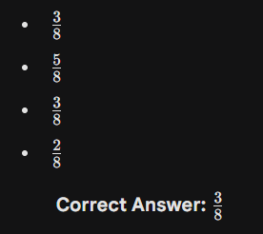
sori di ma type ung over

